DIT5411 Project Report
Student: Law Ka Cheuk
Student No.:240229556

Report on Developing RNN, LSTM, and BiLSTM Models for Hong Kong Daily Minimum Grass Temperature Forecasting

Introduction
This project focuses on forecasting Hong Kong's daily minimum grass temperature using Recurrent Neural Networks (RNNs), Long Short-Term Memory (LSTM) networks, and Bidirectional LSTMs (BiLSTMs). These models were trained on historical data from the Hong Kong Observatory (HKO) spanning 1980–2024 and tested on unseen data from January 1, 2025, to October 30, 2025. The goal is to evaluate the models' ability to capture temporal dependencies and provide accurate forecasts.
Objectives
- Preprocess univariate time-series data for deep learning.
- Implement and compare RNN, LSTM, and BiLSTM architectures.
- Evaluate model performance using metrics like Mean Absolute Error (MAE) and Root Mean Squared Error (RMSE).
- Interpret results in the context of Hong Kong's climate patterns.
Dataset and Preprocessing
Dataset Source
- Source: Hong Kong Observatory (HKO)
- Period Covered: 1980-2025.
- Structure: Columns include Date, Grass Minimum Temperature (°C), and Completeness.
Preprocessing Steps
- Handling Missing Data: Missing values were filled using time-based interpolation.
- Normalization: Data values were scaled to the range [0, 1] using Min-Max normalization.
- Sequence Creation: A sliding window of 30 days was used to create sequences for the models, where 30 days of input predicted the temperature of the next day.
Model Development
Architecture Overview
- RNN: A simple Recurrent Neural Network with one recurrent layer and a dense output layer.
- LSTM: A stacked LSTM with two layers and dropout regularization.
- BiLSTM: A Bidirectional LSTM with dropout, enhancing the model's ability to capture dependencies from both past and future contexts.
Training Setup
- Sequence-to-One Prediction:
  - Input: 30 days
  - Output: Next day's temperature.
- Optimization: Adam optimizer with a learning rate of 0.001.
- Loss Function: Mean Squared Error (MSE).
- Epochs: 100.
- Batch Size: 32.

Results and Analysis
Performance Metrics
The table below summarizes the performance of the models on the unseen 2025 test set:
Model | Test Mean Absolute Error (°C) | Test Root Mean Square Error (°C)
RNN | 0.977 | 1.310
LSTM | 0.926 | 1.289
BiLSTM | 0.933 | 1.271
Observations
- LSTM Outperforms RNN: The LSTM model achieved better performance than the RNN due to its ability to handle long-term dependencies more effectively.
- BiLSTM Marginally Outperforms LSTM: The BiLSTM model achieved the lowest RMSE, showcasing its ability to utilize bidirectional context.
- Error Distribution: Both LSTM and BiLSTM models exhibited narrow error distributions, indicating robustness.
Visual Analysis
- Temperature Forecast: The figure below depicts actual vs. predicted temperatures for 2025. All models closely follow the actual trend.
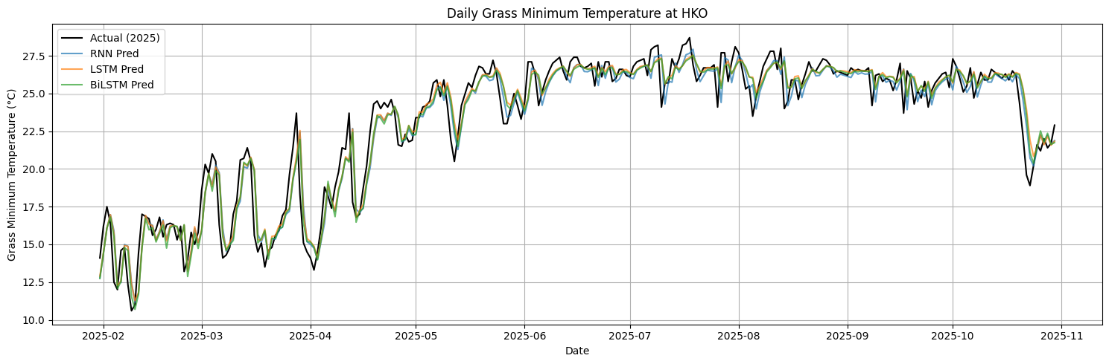
- Error Bands (LSTM and BiLSTM): The confidence intervals suggest reliable predictions, especially for the BiLSTM model.
  - LSTM 95% Confidence Band:
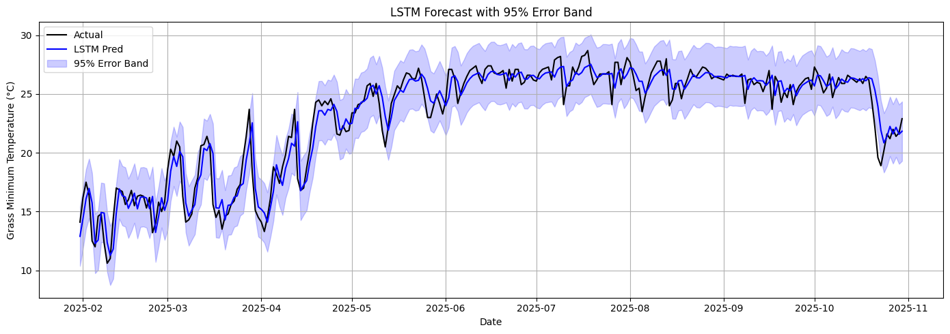
  - BiLSTM 95% Confidence Band:
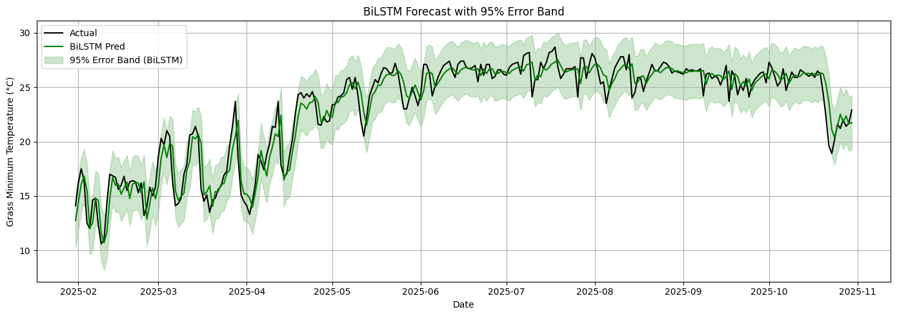

- Error Distribution: The histogram shows the distribution of prediction errors for LSTM and BiLSTM models:
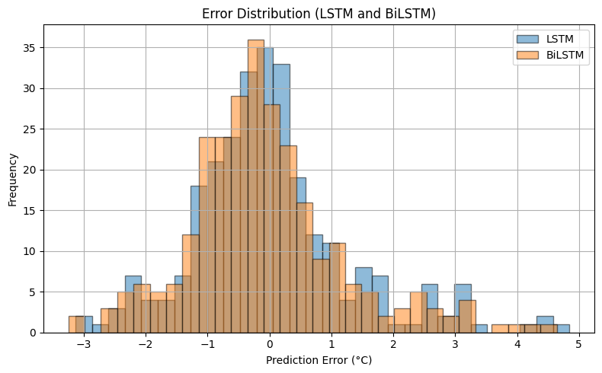

Comparative Analysis
Strengths of LSTM and BiLSTM
- LSTM: Captures long-term dependencies, mitigates vanishing gradients, and adapts well to seasonal climate trends.
- BiLSTM: Incorporates bidirectional context, resulting in enhanced performance during periods of rapid temperature change (e.g., winter lows).
Limitations of RNN
- Struggles with long-term dependencies due to vanishing gradient issues, leading to inferior performance compared to LSTMs.

Error Analysis
Extreme Cases: Errors were higher during abrupt temperature changes, such as cold snaps.
Example from LSTM:
Date: 2025-10-15, True: 14.5 °C, Predicted: 16.7 °C, Error: +2.2 °C
Insights: Model accuracy diminishes during extreme conditions, suggesting potential benefits from incorporating external meteorological features.

Conclusion
This study demonstrated the superiority of LSTM-based models for forecasting Hong Kong's daily minimum grass temperature. While all models performed reasonably well, the BiLSTM model achieved the best overall results, which is the most suitable for this task.

GitHub Repository
The complete code, models, and results are available on GitHub.

References
- Daily grass minimum temperature | DATA.GOV.HK. (n.d.). https://data.gov.hk/en-data/dataset/hk-hko-rss-daily-grass-min-temp

